A117-Eur-Magna Graeca-Salt Cellar Bowl-90o Rim-Blackware-Red Slip on Foot-c 4th century BCE

 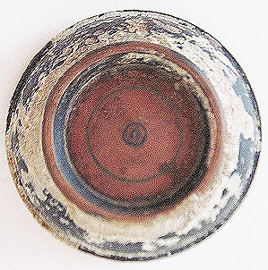

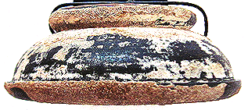

Figs. 1-3. Eur-Magna Graeca-Salt Cellar Bowl-90o Rim-Blackware-Red Slip on Foot-c 4th century BCE

Case no.: 4

Accession Number: A117

Formal Label: Eur-Magna Graeca-Salt Cellar Bowl-90o Rim-Blackware-Red Slip on Foot-c 4th century BCE

Display Description:

With a deep bowl. The remaining surface is smooth and glossy, red slip on foot.

LC Classification: NA279.M3

Date or Time Horizon: 4th c BCE

Geographical Area: Magna Graeca

Map:

GPS coordinates:

Cultural Affiliation: 4th c BCE Magna Graeca

Media: ceramic black glaze

Dimensions: Dia 103.42 mm, 4.07 in

Weight: 109 gm, 3.75 oz

Condition: original

Provenance: old English collection

Discussion: this is a common salt cellar of the age

References: